Routers and SwitchesTheory

- Draw a labelled diagram of a typical home WiFi router and a network switch, clearly marking at least 3 different ports (such as WAN, LAN, Console) and the location of status LEDs.
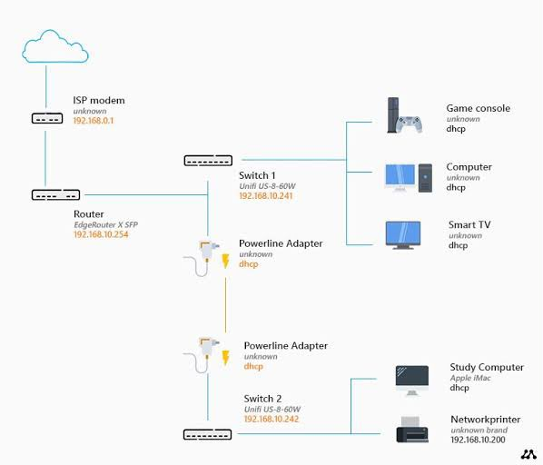
- List 3 key differences between routers and switches in terms of their main functions and how they handle network traffic.<br><br><em><strong>Hint:</strong> Think about how each device deals with IP addresses, MAC addresses, and the types of networks they connect.</em>

Feature | Router | Switch
Main Function | Connects different networks (e.g., a home network to the internet) and routes data between them. | Connects devices within the same network (e.g., computers, printers, and servers in a LAN).
Address Handling | Uses IP addresses to decide where to send data packets. | Uses MAC addresses to forward data frames to the correct device.
Network Traffic Handling | Manages traffic between different networks and chooses the best path for data transfer. | Manages traffic inside a local network by sending data only to the intended device, reducing unnecessary traffic.

- Take a real or virtual image of a router and a switch (from your home, lab, or Google Images), and identify the following on each: Power port, at least 2 Ethernet ports, and any LED indicators. Annotate the image or describe their position and purpose.
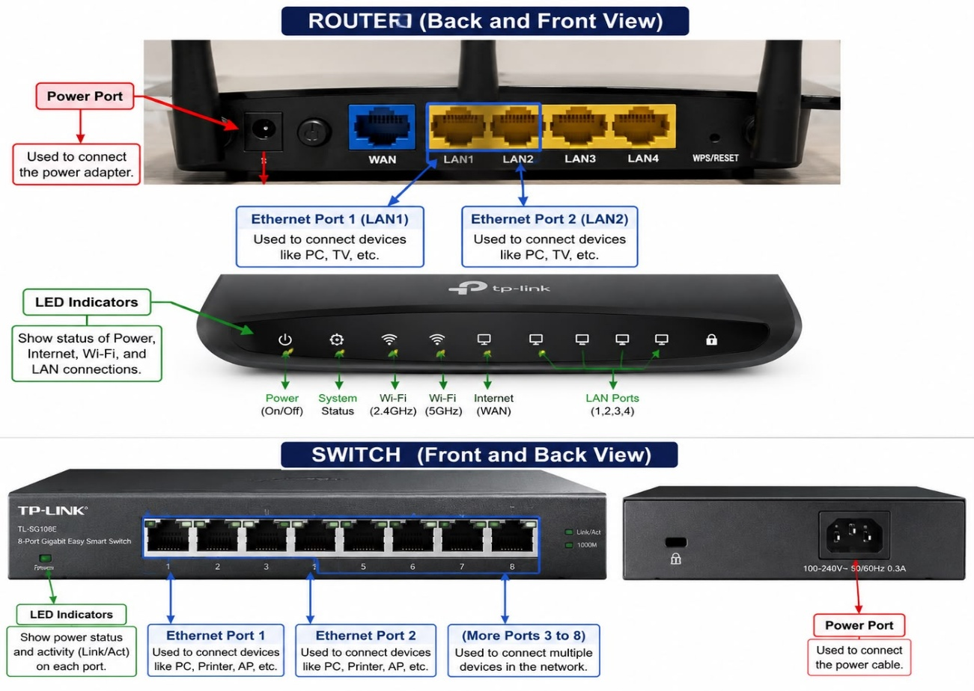
- Imagine you are setting up a small gaming café network for IPL streaming and multiplayer matches. Write a short scenario explaining which device (router or switch) you would connect first to the ISP line, and how you would connect 8 gaming PCs to the network. Justify your choice

- Scenario: Setting up a Gaming Café Network
- For a small gaming café, I would connect the router first to the ISP (Internet Service Provider) line because the router is responsible for connecting the café’s local network to the internet. It will handle IP addresses, provide internet access, and manage traffic for IPL streaming and online multiplayer games.
- After connecting the router, I would connect a network switch to the router using an Ethernet cable. Then, I would connect the 8 gaming PCs to the switch using separate Ethernet cables.
- Network Setup:
- ISP Line → Router → Switch → 8 Gaming PCs

